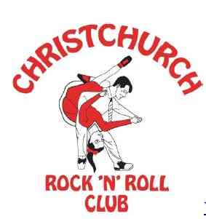**Christchurch Rock’n’Roll Club**

**“Music Mondays”**

**Club Night**

**Upstairs at Hornby Club**

**Monday 7th July**

**Music by DJ Gordon**

**7.15 pm - 9.30 pm**

**All Welcome!**

**Grab a drink from the bar downstairs and come along for non-stop Rock’n’Roll Music**

**Plus “Learn a Move”   
at 7.00pm**

**Door Charges: Members $3 Non Members $6**

**Members’ Club Night Concession Cards   
$15 for 5 nights + 1 free or $30 for 10 nights + 2 free**

[www.christchurchrocknroll.org.nz](http://www.christchurchrocknroll.org.nz)